*Programmer: Javier Valerio  
Date Submitted: February 20th, 2017  
Dr. Shrivastava  
CS 481 – Online Ordering System*

Android App: **Menu Ordering System Part 2**

***Please refer to page 3 for a detailed description for part 2.***

My Android application is implemented and designed to behave/resemble as a menu ordering online system where the user selects the items to be ordered and is allowed to choose among different options. The first View of my app displays the menu; the items are selected from a spinner which has three item categories: Food, Drinks, and Dessert.

Once a particular item is selected, the user chooses the size and quantity.

At this point, the user can either keep adding items into the cart or go to checkout. In case the user adds the same item twice with the same size, the quantity of that item in the cart is simply updated; otherwise, it is added as a separate item.

Upon clicking the **Continue to Checkout** button, the app shows a summary of the cart items and their details. At the bottom of this View, the subtotal, taxes, and total values are displayed. The summary of order details is inside a scrollable *TextView* so whenever there are more items that fit the screen, the user can simply scroll up/down.

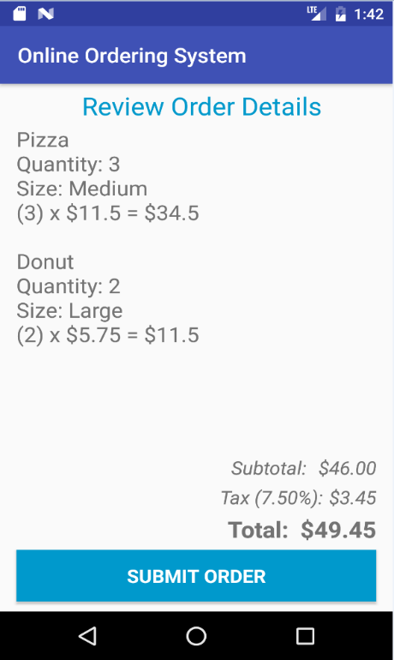

When the **Submit Order** button is clicked, the app redirects the user to another layout where he/she can how long the order will take. For simplicity purposes, I set the waiting time per item to be 5 seconds. So for instance, if there are 3 items (regardless of the size), the total waiting time will take 15 seconds. There will be a timer for this total waiting time and when it reaches 0, the app switches layouts and informs the user that the order is ready.

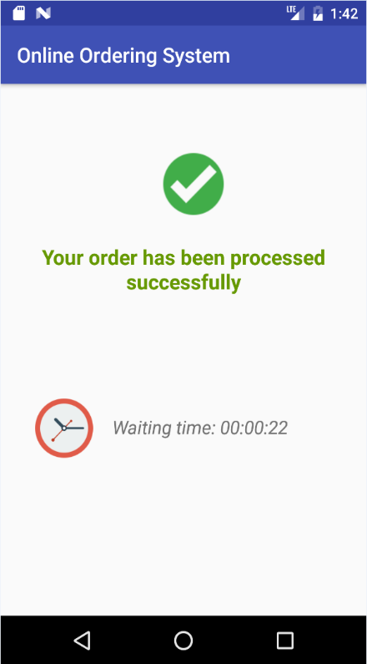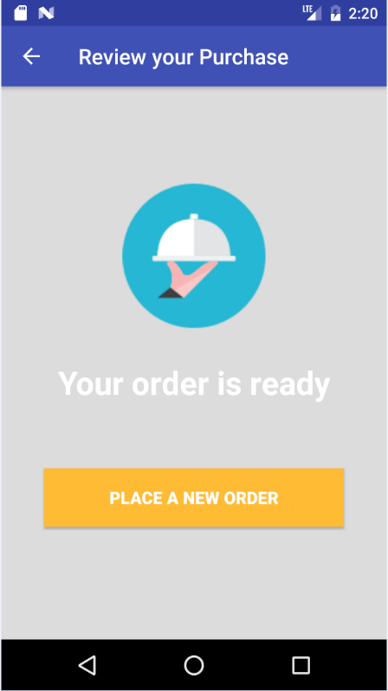

More screenshots from Part I are in the *screenshots_old-version/* folder directory.

Part II:

In the second part of my application, I changed some of the main layouts and updated the logic in the corresponding Java classes.

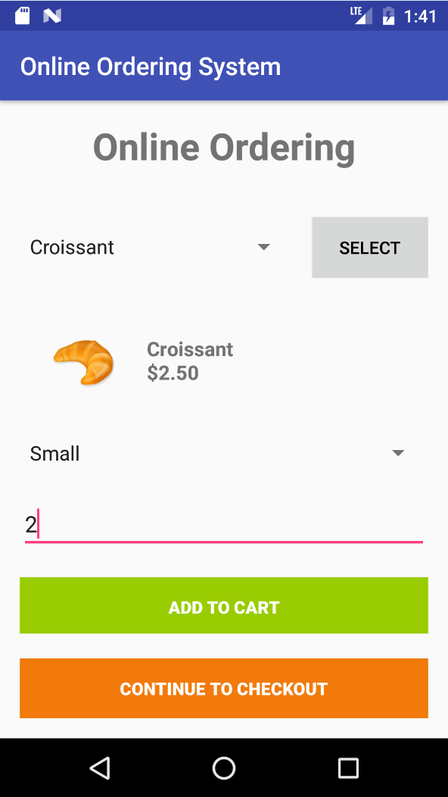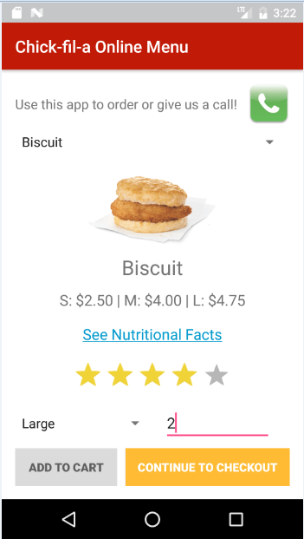In the Main Activity, I made significant improvements on the layout. Below are the old and new versions for the main layout:

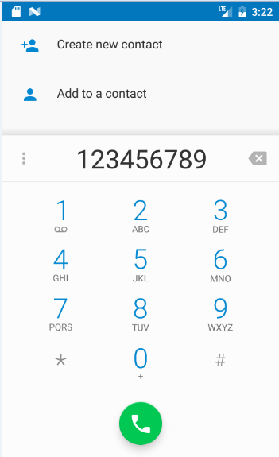In the first version, the user had to click the ‘Select’ button in order to select the chosen item from the spinner. In the new version, I implemented an Action Listener to when an item is selected from the spinner so the flow is easier to follow and understand for the user. On top, I also added a Make a Call button in case the user decides to call rather than to use the app. To the left is a screenshot to when the user presses the Call button.

I also added a Nutritional Facts link that opens in the web browser redirecting the user to see the nutritional facts for the particular item chosen. Similarly, I implemented a customer rating system where the user selects the rating for that particular item and when another user uses the app, he/she will see the rating from the previous customer.

Furthermore, I also modified the layout for reviewing the order. The differences are highlighted in the below pictures:

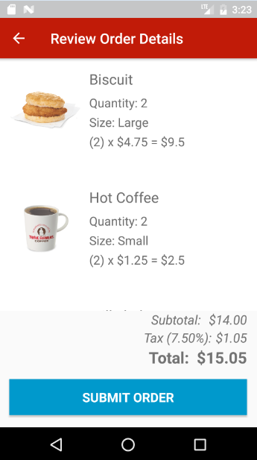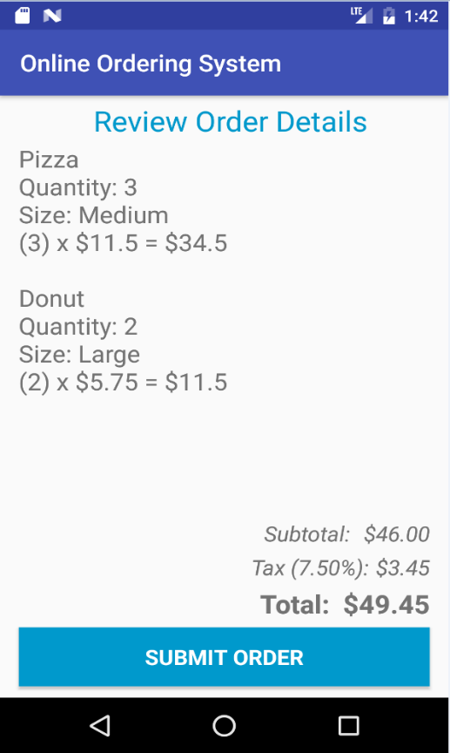

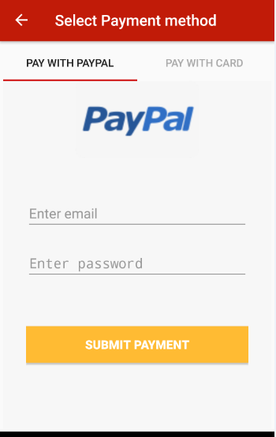In the first version, I displayed a concatenated String containing all the items details and bind this data into a Text View. This is the reason I could not place the items’ images into the Text View. In the second version, I used a Grid and an Adapter to display each item’s details into a separate column (in order to make it more presentable to the user).

When the submit order is clicked, the app sets a new layout: the Payment layout. Here the user selects from two payment types: PayPal or credit card. To proceed with the order, please use [test@test.com](mailto:test@test.com) as email and test as password if the PayPal method is selected. For paying with credit card, use the digits 123456789 and CCV is 001. Any other credentials and/or CC digits will not work.

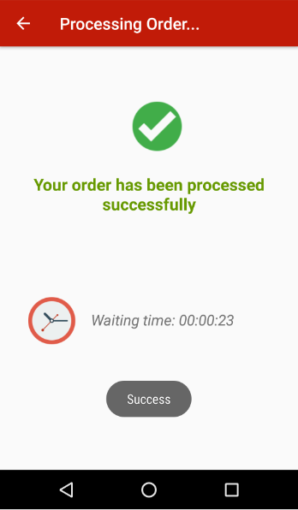This View is displayed when the order is being processed and after the payment has been made. For simplicity, each ordered item takes 5 seconds to prepare. In the example to the left, the time was set to 25 seconds (a total of 5 items were ordered). Once this countdown expires, the app switches to another View one more time indicating that the user is now ready. Enjoy!

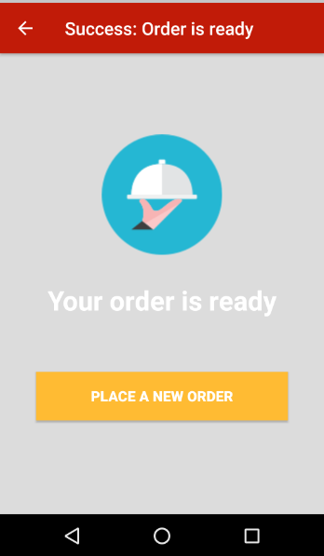

More screenshots of Part II are in the ***screenshots_new-version/*** folder directory.